Матрица связей в БД AirSharing
 | User/E1 | FlightLicense/E2 | Aircraft/E3 | AircraftCategory/E4 | Passport/E5 | AircraftInfo/E6 | AircraftCoordinates/E7 | Admin/E8 | Rental/E9 | AircraftRegistrCertificates/E10 | Airfield/E11 | ServiceInfo/E12 | AircraftInsurance/E13 | Employee/E14 | MoneyTransaction/E15 | LeasingCompany/E16 | LeasingInfo/E17 | PaymentInfo/E18
User/E1 |  | R1 |  |  | R2 |  |  | R3 | R4 |  |  |  |  |  | R5 |  |  | R6
FlightLicense/E2 | R1 |  |  |  |  |  |  |  | R7
Aircraft/E3 |  |  |  | R9 |  | R10 | R11 |  | R12 | R13 |  | R15 | R16 |  |  |  | R17
AircraftCategory/E4 |  |  | R9
Passport/E5 | R2 |  |  |  |  |  |  |  |  |  |  |  |  | R18
AircraftInfo/E6 |  |  | R10
AircraftCoordinates/E7 |  |  | R11
Admin/E8 | R3
Rental/E9 | R4 | R7 | R12 |  |  |  |  |  |  |  |  |  |  |  | R19
AircraftRegistrCertificates/E10 |  |  | R13 |  |  |  |  |  |  |  |  |  |  |  |  | R20
Airfield/E11 |  |  |  |  |  |  |  |  |  |  |  | R21 |  | R22
ServiceInfo/E12 |  |  | R15 |  |  |  |  |  |  |  | R21 |  |  | R23
AircraftInsurance/E13 |  |  | R16 |  |  |  |  |  |  |  |  |  |  |  |  | R24
Employee/E14 |  |  |  |  | R18 |  |  |  |  |  | R22 | R23
MoneyTransaction/E15 | R5 |  |  |  |  |  |  |  | R19
LeasingCompany/E16 |  |  |  |  |  |  |  |  |  | R20 |  |  | R24 |  |  |  | R25
LeasingInfo/E17 |  |  |  |  |  |  |  |  |  |  |  |  |  |  |  | R25
PaymentInfo/E18 | R6

Логическая схема БД AirSharing в TOAD data modeler. На уровне Ключей и атрибутов
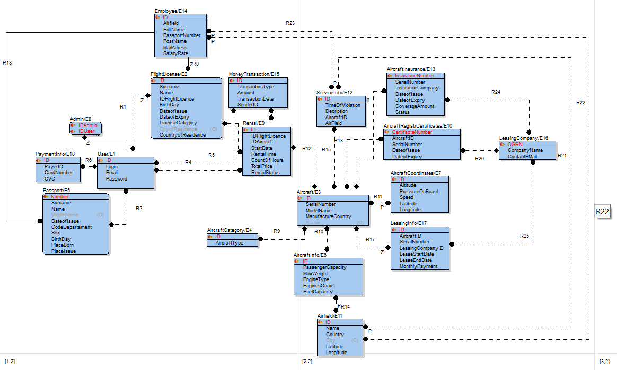
Физическая модель AirSharing в TOAD data modeler. С указанием связей, ключей, атрибутов и их типов
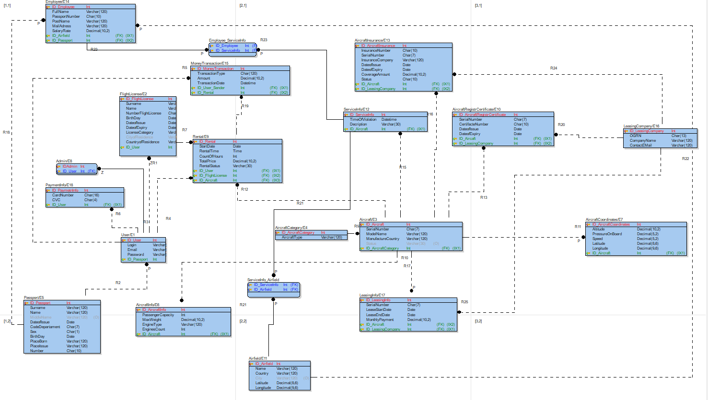
C:\Users\lobzi\OneDrive\Документы\Toad Data Modeler\GeneratedScripts\Generated.SQL

